**AMERICAN INTERNATIONAL UNIVERSITY–BANGLADESH (AIUB)**

**Dept. of Computer Science**

**Faculty of Science and Technology**

**CSC2210: OBJECT ORIENTED PROGRAMMING 2**

**Fall 2024-2025**

**Section: B**

**Group No: 0012**

**Project Report On**

*Project Name [****Filling Station Management]***

**Supervised By**

**Md. Hasibul Hasan**

**Submitted By:**

|  |  |
| --- | --- |
| **Name** | **ID** |
| **1. Faysal Ahammed Chowdhury** | **22-49046-3** |
| **2. Md Shamsul Alam Pranto** | **22-50000-3** |
| **3. Asef Abdullah** | **22-49923-3** |

|  |  |  |  |  |  |  |  |
| --- | --- | --- | --- | --- | --- | --- | --- |
| **Obtained Marks for CO2 and CO3 (Description given in the following page)** | | | | | | | |
| **Assessment Criteria** | **Not Attended/ Incorrect (0)** | | **Inadequate  (1-2)** | | **Average (3)** | **Good  (4)** | **Excellent (5)** |
| **Evaluation Criteria (CO2)** | | **Total =** | | **Evaluation Criteria (CO3)** | | | **Total =** |
| Requirement fulfillment | |  | | Organization of the application | | |  |
| Validation | |  | | Representation and Integration of Database | | |  |
| Verification | |  | | Graphical User Interface | | |  |

|  |  |  |  |  |  |  |  |  |  |
| --- | --- | --- | --- | --- | --- | --- | --- | --- | --- |
| **CO2:** Display and verify the mean of a real-life Project using the concepts of C# Graphical User Interface based environment with database integration to depict a desktop-based application. | | | | | | | | | |
| **Assessment Criteria** | **Not Attended/ Incorrect (0)** | **Inadequate  (1-2)** | | **Average (3)** | | **Good  (4)** | | **Excellent (5)** | |
| **Evaluation Criteria** | **Evaluation Definition** | | | | | | | | |
| Requirement fulfillment | Fails to demonstrate any understanding of real-life scenario-based project development or functional requirement identification. There is no attempt to depict a project or identify functional requirements accurately. | | Demonstrates limited understanding of real-life scenario-based project development and functional requirement identification. The project depicted lacks coherence or relevance to real-life scenarios, and functional requirements are inaccurately identified or insufficiently described. | | Presents a basic depiction of a real-life scenario-based project and identifies some functional requirements. However, the project lacks depth or complexity, and some functional requirements may be vaguely defined or missing key details. | | Effectively demonstrates a realistic scenario-based project and accurately identifies most functional requirements. The project is well-developed with appropriate complexity, and functional requirements are clearly articulated with relevant details. | | Exhibits an exceptional understanding of real-life scenario-based project development and accurately identifies all functional requirements. The project is meticulously developed with thorough attention to detail, reflecting a comprehensive understanding of Object-Oriented Programming project development activities. |
| Validation | Fails to demonstrate any understanding or implementation of validation forms in their system. There is no attempt to deal with data validation, and validation requirements are completely ignored or incorrectly applied. | | Demonstrates limited understanding of validation forms and data validation techniques. While some attempt may be made to implement validation, it is incomplete or poorly executed, leading to inadequate handling of data validation. | | Shows a basic understanding of validation forms and data validation techniques. They attempt to implement validation, but some aspects may be missing or incorrectly implemented, resulting in partial or inconsistent handling of data validation. | | Effectively demonstrates the use of validation forms and implements data validation techniques. Validation is mostly accurate and comprehensive, ensuring the proper handling of data input and verification in the system. | | Exhibits an exceptional understanding and implementation of validation forms and data validation techniques. Validation is meticulously implemented with thorough attention to detail, ensuring robust data validation procedures and contributing to the overall reliability and integrity of the system. |
| Verification | Fails to demonstrate any attempt to verify the system data or functional requirements. There is no evidence of understanding or implementation of verification processes, and data flow is not considered. | | Demonstrates limited understanding of verification processes and data flow in the system. Verification attempts are incomplete or inaccurate, and there is insufficient consideration given to ensuring data integrity and functionality. | | Shows a basic understanding of verification processes and attempts to verify system data. However, verification efforts may be inconsistent or lack thoroughness, and there may be gaps in ensuring proper functional requirements and data flow. | | Identifies and verifies system data, ensuring proper functional requirements are met. Verification efforts are mostly accurate and thorough, with attention to ensuring data integrity and appropriate data flow within the system. | | Exhibits an exceptional understanding of verification processes and meticulously verifies system data. Verification efforts are comprehensive and precise, with a keen focus on ensuring all functional requirements are met and maintaining proper data flow throughout the system. |

|  |  |  |  |  |  |  |  |  |  |
| --- | --- | --- | --- | --- | --- | --- | --- | --- | --- |
| **CO3:** Prepare and Explain a real life desktop based application synthesizing several component of C# along with development tools to adhere the given requirements. | | | | | | | | | |
| **Assessment Criteria** | **Not Attended/ Incorrect (0)** | **Inadequate  (1-2)** | | **Average (3)** | | **Good  (4)** | | **Excellent (5)** | |
| **Evaluation Criteria** | **Evaluation Definition** | | | | | | | | |
| Organization of the application | Fails to identify any suitable real time application or requirements for project development activities related to OOP. | | Limited understanding about the project scopes and scenarios or identification of functional requirements. | | Lacks depth or relevance to OOP project development activities and may contain inaccuracies. Real-life scenarios are mentioned, but the discussion lacks depth or clarity. | | Consider and integrate the idea of several core aspects of the project along with relevance to real-life scenarios. Demonstrating a solid understanding of the application presentation. | | Generalize and exhibits an exceptional understanding of project preparation according to a to real-life scenarios. Also contains proper and insightful identification of the system which is comprehensive and precise. |
| Representation and Integration of Database | Fails to identify and present any understanding or implementation of database. Also failed to integrate the data with the project itself. | | Limited understanding of the database concepts or their proper way of using in a real time project. While some attempt may be made to implement but it is incomplete or poorly executed, leading to inadequate design. | | Lacks depth or relevance to database integration with the application. Shows a basic understanding but some aspects may be missing or incorrectly implemented, resulting in partial or inconsistency. May lack proper normalization. | | Integrate the database with the forms properly and implements it with proper validation which is mostly accurate and comprehensive, ensuring the proper handling of data input and verification along with general normalization. | | Exhibits an exceptional understanding and implementation of database ensuring attention to detail, and robust data manipulation procedures and contributing to the overall clarity. |
| Graphical User Interface | Fails to present or prepare GUI based application interfaces. There is no evidence of creating or integrating such things according to their usefulness. | | Limited understanding of graphical user interfaces. Lack of design knowledge. Very poor attempt to make such things which are currently obsolete or can’t be identified as coherent. | | Shows a basic understanding of creating user interfaces. Most of them are interconnected but maybe some of them lack it. However, most of it can be described as user friendly. | | Effectively identifies and meet the consider the simplicity. Design related works are mostly accurate and taken proper attention to ensuring a user-friendly coherent system. | | Exhibits an exceptional work design following a high standard of simple and elegant work. Several controls and mechanism has been organized in a preferred way according to the coherent usage . |

**Table of Contents: Page no.**

1. Chapter: 01 (Introduction)----------------------------------------------------------------------- 02

2. Chapter: 02 (User Story)------------------------------------------------------------------------- 02

3. Chapter: 03a (ER Diagram)---------------------------------------------------------------------- 03

4. Chapter: 03b (SQL Queries)--------------------------------------------------------------------- 06

5. Chapter: 04 (Screenshots)------------------------------------------------------------------------ 09

1. ***Introduction***

The **Filling Station Management System** is a desktop-based application developed using C# and MSSQL to help manage daily operations at a filling station more efficiently. It provides a simple graphical user interface that allows users to handle sales, inventory, expenses, and employee/user records with ease. The system reduces manual work, ensures proper record-keeping, and helps in tracking fuel stock, transactions, and employee activities. There are two types of users: Admins, who have full access to all features, and Employees, who can only add sales and expenses. This system makes managing a filling station easier by keeping all important data organized and reducing errors.

1. ***User Story***

The Filling Station Management System has two types of users: **Admin** and **Employee**.

**Admin**

**Sales Management**

* Can add, view, and delete sales records.
* Can search sales history by Sale ID or date range.
* Can view sales reports (daily, weekly, monthly, or custom date range).
* After a sale is completed, an invoice is generated, which can be accessed later by clicking on the sale details.
* When adding a sale, the inventory is displayed on the left side, and fuel can be searched by name.

**Inventory Management**

* Can view, search, add, edit, and delete inventory records.
* Can search inventory by fuel name for quick access.

**User Management**

* Can view, search, add, edit, and delete users.
* Can search users by name and filter by Admin, Employee, or All.
* Employees cannot register themselves; only an Admin can add them.

**Expense Management**

* Can add, view, and delete expense records.
* Can search expenses by category and filter by date range.
* Can view expense reports (daily, weekly, monthly, or custom date range).

**System Behavior and Updates**

* If an Admin updates their role, they are logged out immediately.
* If an Admin changes their name/information, the updated name/information is instantly reflected across the system.

**Employee**

* Can add sales and add expenses.
* After completing a sale, an invoice is generated for reference.
* On the dashboard, can view today’s sales list, the total amount made by her/him, and a real-time clock.
* When adding a sale, the inventory is displayed on the left side, and fuel can be searched by name.

1. ***ER Diagram***

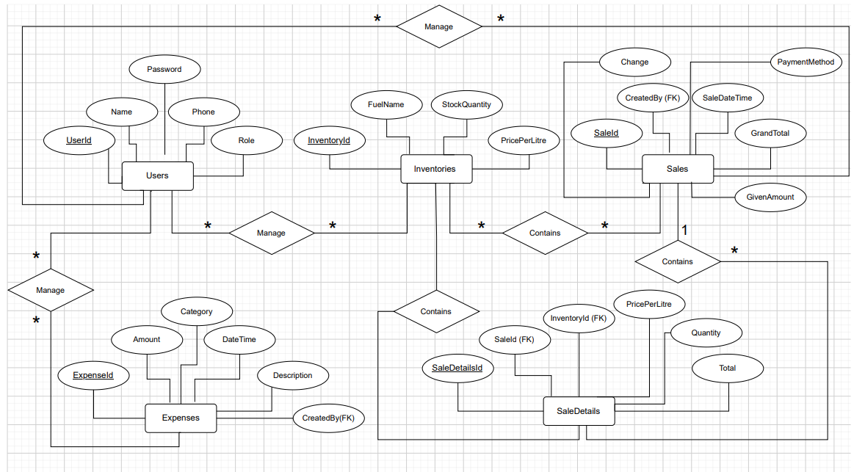

***Fig-1. Entity Relationship Diagram***

1. ***SQL Queries:***

* **Login**

1. SELECT * FROM Users WHERE Username = '{username}' AND Password = '{password}';
2. SELECT * FROM Users WHERE UserId = '{userId}';
3. ***Screenshots***

jer